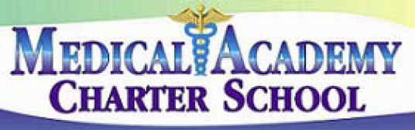 **No. 101**

**SECTION: PROGRAMS**

**TITLE: MISSION AND VISION STATEMENTS**

**MEDICAL ACADEMY ADOPTED: 10/8/13**

**CHARTER SCHOOL REVISED:**

101. MISSION AND VISION STATEMENTS

The **Mission** of the Medical Academy Charter School is:

The mission of Medical Academy Charter School (MACS) is to prepare students for future careers in the rapidly growing health care sciences industry. This will be accomplished by providing a comprehensive, rigorous curriculum with a strong health care sciences focus and through the involvement with individuals and organizations that represent the health care sciences industry. Upon graduation, students will be expected to enter either technical or college degree programs in the health care sciences.

The **Vision** of the Medical Academy Charter School is:

The school’s overarching vision is to prepare high school students for future careers in the health care sciences industry. Our vision will be achieved by providing a comprehensive, rigorous curriculum that provides students with the skills and knowledge they need to succeed as health care professionals and to function as productive members of society.