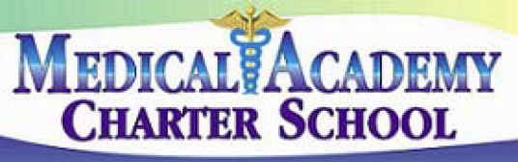 **No. 218**

**SECTION: PUPILS**

**TITLE: DRESS AND GROOMING**

**MEDICAL ACADEMY ADOPTED: 10/8/13**

**CHARTER SCHOOL REVISED:**

218. DRESS AND GROOMING

The Board recognizes that each student's mode of dress and grooming is a manifestation of personal style and individual preference.

The Board has the authority to impose limitations on students’ dress in school. The Board will not interfere with the right of students and their parents/guardians to make decisions regarding their appearance, except when their choices disrupt the educational program or constitute a health or safety hazard as long as students are dressed in the proper school uniform.

Students may be required to wear certain types of clothing while participating in physical education classes, technical education, extracurricular activities, or other situations where special attire may be required to ensure the health or safety of the student.

The Principal/CEO or designee shall be responsible to monitor student dress and grooming, and to enforce Board policy and school rules governing student dress and grooming.

The Principal/CEO or designee shall ensure that all rules implementing this policy impose only the minimum necessary restrictions on the exercise of the student’s taste and individuality.

Staff members shall be instructed to demonstrate, by example, positive attitudes toward neatness, cleanliness, propriety, modesty, and good sense in attire and appearance.

References:

School Code – 24 P.S. Sec. 1317.3

State Board of Education Regulations – 22 PA Code Sec. 12.11