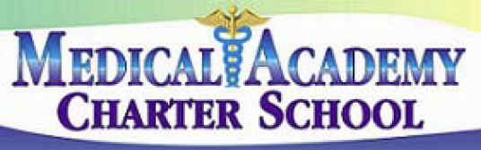 **No. 116**

**SECTION: PROGRAMS**

**TITLE: CURRENT EVENTS**

**MEDICAL ACADEMY ADOPTED: 10/8/13**

**CHARTER SCHOOL REVISED:**

116. CURRENT EVENTS

The Board believes that consideration of current events has a legitimate place in the educational program of the schools. Properly introduced and conducted, discussion of such events can help students learn to identify important issues, explore fully and fairly all sides of an issue, weigh carefully the values and factors involved, and develop skills for formulating and evaluating positions.

For purposes of this policy, a current event is a topic on which opposing points of view have been promulgated by responsible opinion, likely to arouse both support and opposition and not expressly enumerated in the course guide as appropriate for the course of study.

The Board shall permit the introduction and proper educational use of current events, provided that their use in the instructional program:

1. Is related to the course's instructional goals and the students' level of maturity.

2. Does not tend to indoctrinate or persuade students to a particular point of view.

3. Encourages balanced presentations and open-mindedness.

4. Is conducted in a spirit of scholarly inquiry.

5. Is instigated by curricular design or by the students themselves.

6. Is not related to the employment status of the teacher and/or other employees of the school.

In the discussion of any event, a teacher may express a personal opinion but shall identify it as such and must not express an opinion for the purpose of persuading students to his/her point of view.

References:

School Code – 24 P.S. Sec. 510

State Board of Education Regulations – 22 PA Code Sec. 4.4